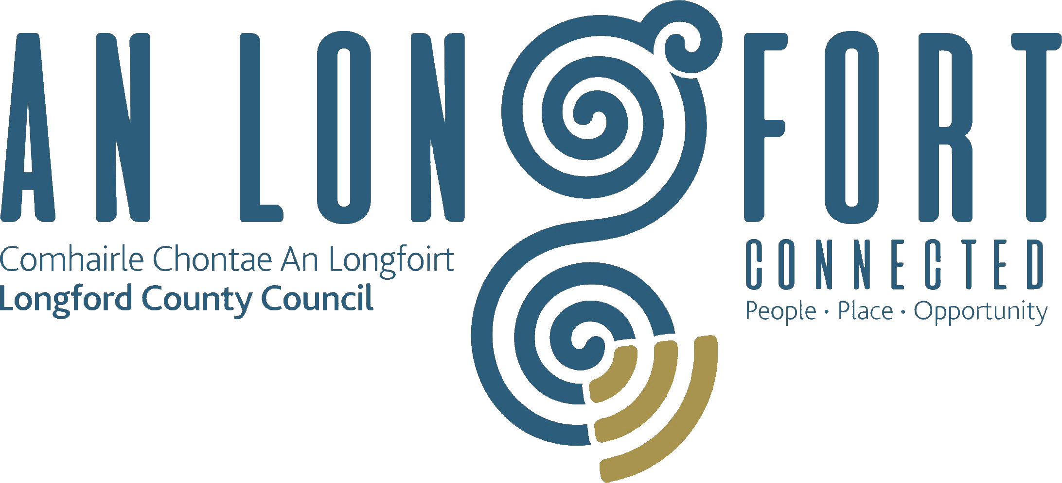

Minutes of Monthly Meeting of Longford County Council
held in the Council Chamber, Aras an Chontae, Great Water Street, Longford on
Wednesday, 11th July 2018 at 4.00 p.m.
____________________________________________________________________

PRESIDING: Councillor Luie McEntire, Cathaoirleach.

MEMBERS PRESENT: Councillors – Paraic Brady, John Browne, Seamus Butler, Mick Cahill, Micheál Carrigy, Mark Casey, Gerard Farrell,
Joe Flaherty, Gerard Hagan, Colm Murray, Peggy Nolan, Pat O’Toole, P.J. Reilly, Paul Ross, Mae Sexton and Gerry Warnock.

APOLOGIES: Councillor Martin Mulleady.

IN ATTENDANCE: Mr. Paddy Mahon, Chief Executive.
Mr. John McKeon, Head of Finance.
Mr. Michael Nevin, Acting Director of Services.
Mr. David Tubridy, Acting Director of Services.
Ms. Mary Carleton-Reynolds, County Librarian.

MEETINGS
ADMINISTRATOR: Ms. Anne Lee.

ADOPTION OF MINUTES.

On the proposal of Councillor P. Nolan seconded by Councillor P. Brady, the Minutes of Monthly Meeting of Longford County Council held on the 13th June 2018, as circulated, were confirmed and adopted.

On the proposal of Councillor S. Butler seconded by Councillor P. Brady, the Minutes of Annual Meeting of Longford County Council held on the 21st June 2018, as circulated, were confirmed and adopted.
MATTERS ARISING FROM MINUTES.

None.

CHIEF EXECUTIVE ORDERS.

The Chief Executive Orders, as circulated, were noted.

MONTHLY MANAGEMENT REPORT.

The Monthly Management Report, as circulated, was noted.

Energy Efficiency Programme - Councillor J. Browne.

Works under Phase 1 are complete.
An application for funding under Phase 2 will be made in 2018.

Incremental Purchase Scheme - Councillor M. Sexton.

It was agreed that a letter be forwarded to the Department of Housing, Planning and Local Government requesting that the Incremental Purchase Scheme should be applicable to tenants who are living in their homes for a minimum of 15 years and that the source of income should not be used to preclude those tenants from availing of the scheme.

It was further agreed that the Local Authority should have more discretion in dealing with individual applications under the Scheme.

CORPORATE POLICY GROUP MINUTES.

The adopted Minutes of Corporate Policy Group Meeting held on the
9th May 2018, as circulated, were noted.

HOUSING, INFRASTRUCTURE, ENVIRONMENT & EMERGENCY SERVICES.

Draft Policy for the use of Vehicle Activated Signs - referred from Infrastructure and Environment Strategic Policy Committee.

On the proposal of Councillor S. Butler seconded by Councillor M. Carrigy, it was unanimously agreed to adopt Draft Policy for the use of Vehicle Activated Signs, as circulated.

It was further agreed that one Vehicle Activated Sign be provided in each Municipal District and the location for these signs to be agreed at Municipal District level.

Civil Defence Application Form - referred from Infrastructure and Environment Strategic Policy Committee.

On the proposal of Councillor P. O’Toole seconded by Councillor M. Carrigy, it was unanimously agreed to adopt Civil Defence Application Form - as circulated - including pricing structure of -
- €150 - Half Day Event (3.5 hours)
- €300 - Full Day Event
- No Charge -Charity Event.

It was further agreed that payment be made following events.

Notice of Motion.

Relocation of Salt & Gritting Barn.

The following Notice of Motion was proposed by Councillor M. Sexton and seconded by Councillor P. Nolan -

“That this County Council relocates the Salt & Gritting Barn on the Park Road to a more convenient location on the edge of town e.g. N4 / N5 /N63.”

D. Tubridy stated that the salt barn was constructed in 2014 . Longford County Council examined several options at the time and concluded that the most appropriate available location was the Machinery Yard .

This tied in with the redevelopment of the yard with in excess of 400k spent on infrastructural improvements in the yard including the salt barn and the provision of a depot for Longford MD. Longford County Council will carry out an operational review with a view to mitigating any complaints from local residents.

FINANCE & INFORMATION SYSTEMS.

Public Liability Claims.

It was noted that two Public Liability Claims were received during June 2018.

ECONOMIC AND COMMUNITY DEVELOPMENT, PLANNING, HUMAN RESOURCES & CORPORATE SERVICES, CULTURAL & RECREATIONAL SERVICES.

Planning Applications.

The list of Planning Applications received since May meeting of the Council was noted.

National Libraries Strategy - “Our Public Libraries 2022 – Inspiring, Connecting and
Empowering Communities”

Mary Carleton-Reynolds, County Librarian, gave a comprehensive presentation regarding the National Libraries Strategy - “Our Public Libraries 2022 – Inspiring, Connecting and
Empowering Communities”, as circulated, and replied to queries raised.

Notice of Motion.

“Ireland’s Hidden Heartlands”

The following Notice of Motion was proposed by G. Warnock and seconded by Councillor M. Carrigy -

“I am proposing that Longford County Council invite representatives from Failte Ireland’s “Ireland’s Hidden Heartlands” Team to address the September meeting of LCC regarding Longford’s place within the new brand. It would be highly beneficial for the Elected Members, the Executive and Administration of LCC to get the opportunity to have a public discussion with the State Agency to explore the many opportunities that this new brand will undoubtedly present for the local authority, the local communities and local enterprise in our efforts to develop Longford as a significant tourism destination.”

It was agreed that a representative from Failte Ireland’s “Ireland Hidden Heartlands” Team be invited to the September meeting of the Council.

The members also expressed disappointment that County Longford is not included in the current television media campaign for “Ireland’s Hidden Heartland”.

M. Nevin briefed the members on the proposed staffing structure of “Ireland’s Hidden Heartlands” Team and stated that he is confident that County Longford will be included in future campaigns.

Regeneration Sub-Committee.

A meeting of the Regeneration Sub-Committee to be arranged.

The members complimented all who were involved with the arrangements for the launch of the Longford MAPS Integrated Action Plan and discussion on Urban Regeneration on Monday, 9th July.

GENERAL.

Notices of Motions.

Fair Deal Scheme.

The following Notice of Motion was proposed by Councillor M. Carrigy and seconded by Councillor P.J. Reilly -

“I call on Longford County Council to support the IFA concerns and proposals about the
treatment of farm assets in relation to the Fair Deal Scheme.”

It was agreed that the Minister for Health be requested to receive a deputation from the Council regarding this issue and the Chairman of County Longford I.F.A. also be invited to attend.

Correspondence – circulated.

(a) Correspondence dated 15th June 2018 received from Dr. John McHugh regarding the Presidency of Ireland was noted.
(b) Correspondence dated 5th June 2018 received from the Office of the Minister for Finance and Public Expenditure and Reform regarding legislation in relation to private equity fund was noted.

This concluded the business of the meeting.
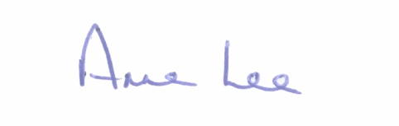

Signed: _______________
Anne Lee,
Meetings Administrator.

Confirmed and adopted at Monthly Meeting of Longford County Council held on the
12th September 2018.

Signed: _______________
Cathaoirleach.

